Nama : Nayottama Satya Hutama

NIM : 18090004

Kelas : 5C

PRAKTIKUM 3

1. Source code

view-form-matakuliah.php => View

view-data-matakuliah.php => View

Matakuliah.php => controller

1. URL

<http://localhost/Pustaka_Booking_Nayottama/matakuliah>

[http://localhost/Pustaka_Booking_Nayottama/matakuliah/cetak](http://localhost/Pustaka_Booking_Nayottama/matakuliahvalidation/cetak)

1. Capture Output Program

Formulir

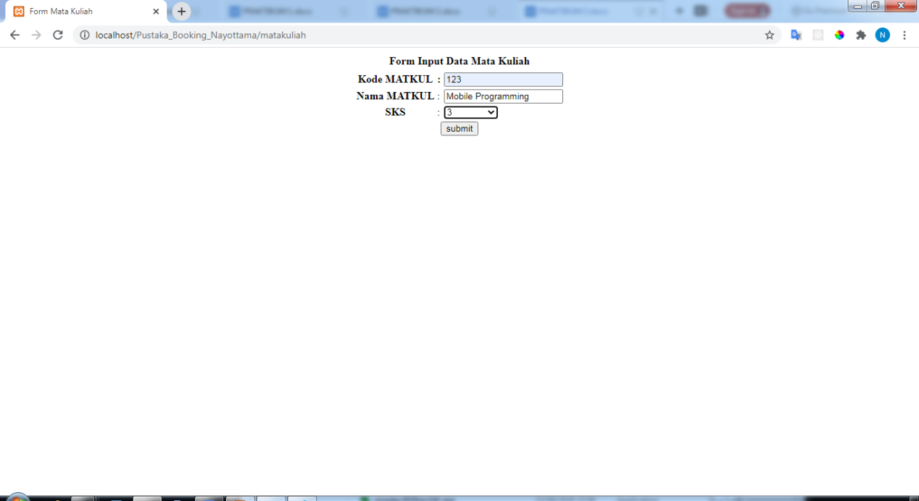

Cetak Formulir

